Maze Runner Backtracking Recursive code

* I changed some code in maze.java for check maze is correctly working or not.
* I found that maze is working well.
* I tried with different-different solving cases and some cases in which there is no solution to solve the maze. If solution is not possible then it shows error and if solution is possible then it solves the maze.

This is the case which we already have

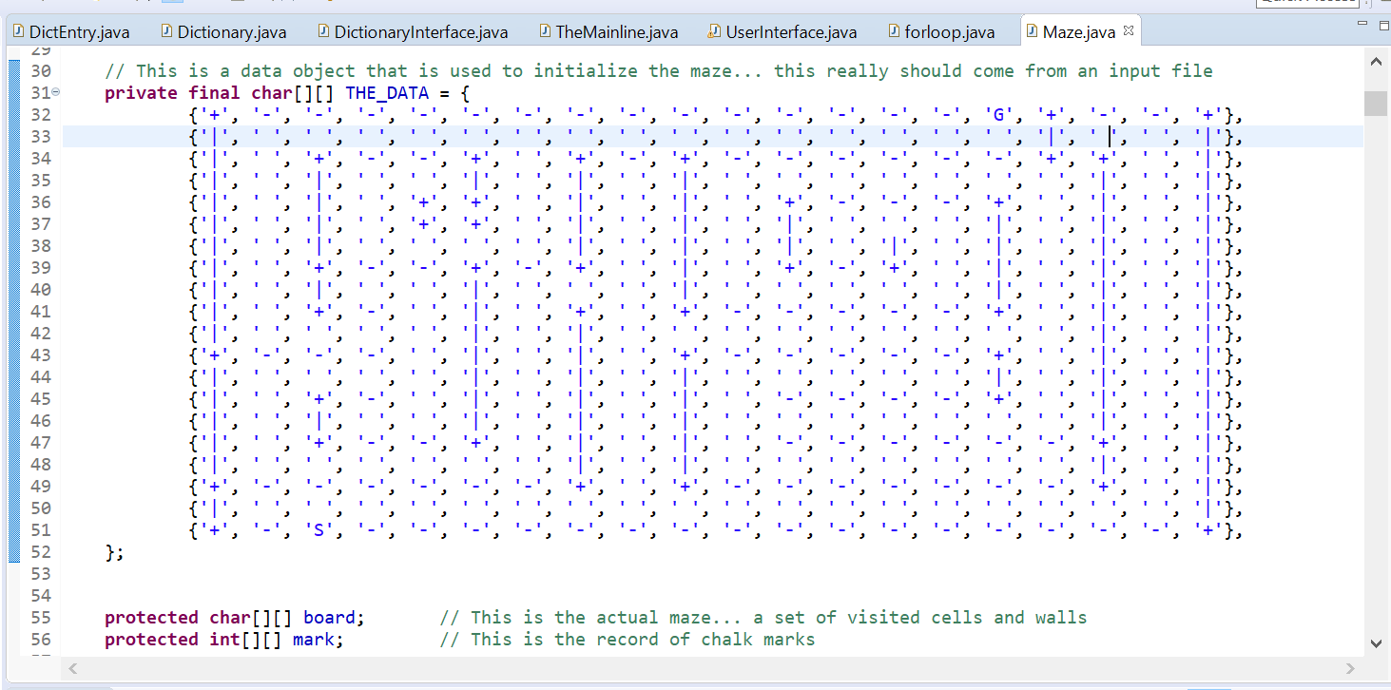

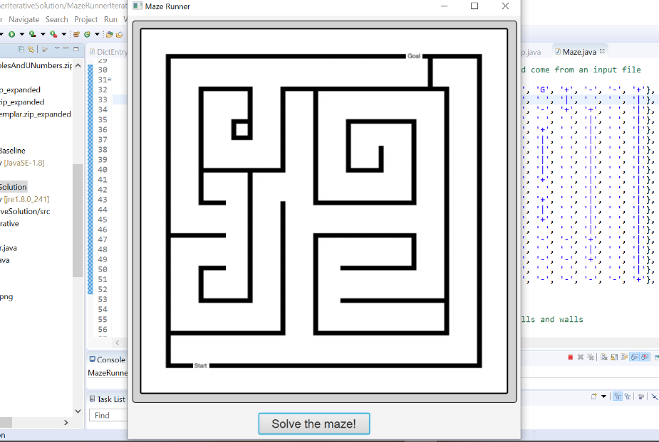

When I click Solve the maze button then it will solve this maze.

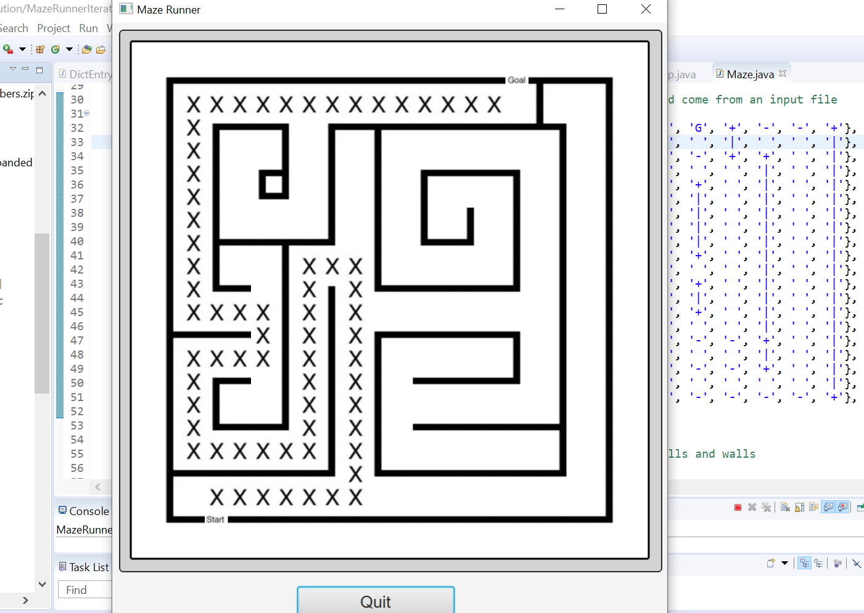

Changing hurdle position in code

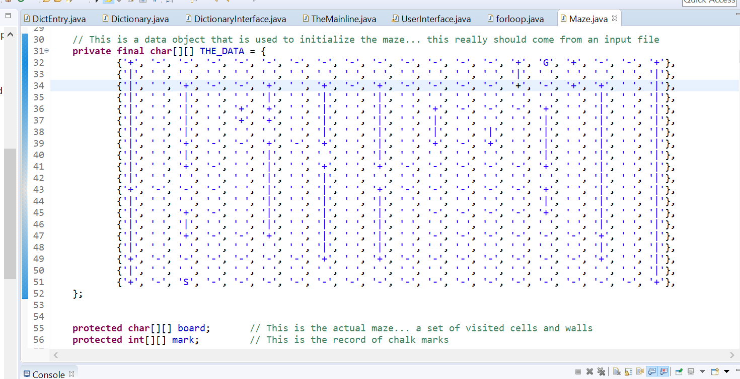

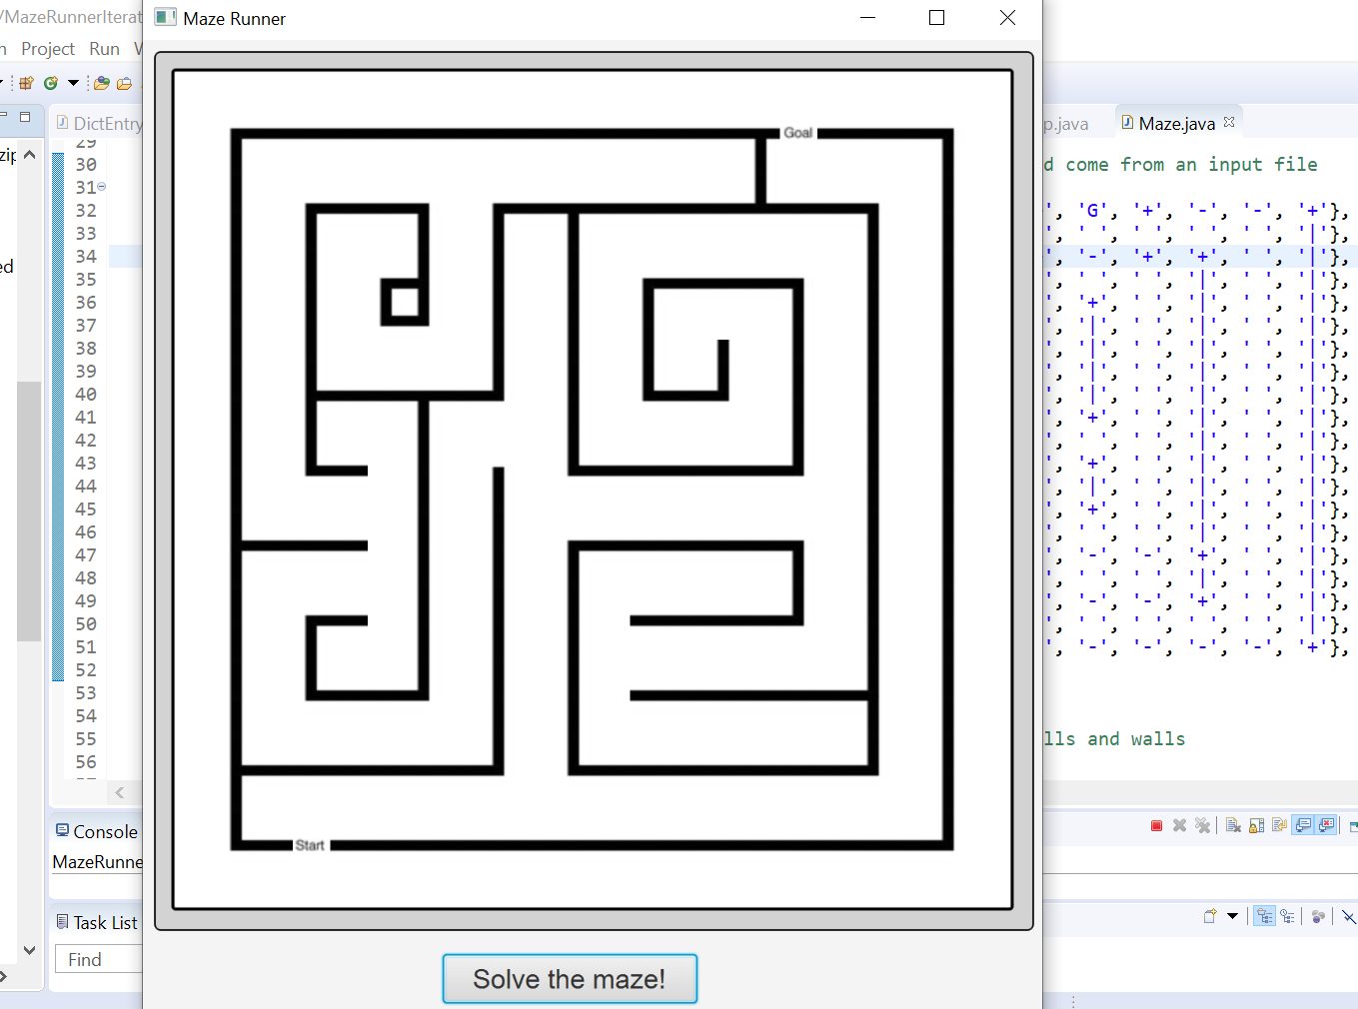

This maze has some other possible solution and it will solved when we click on the button.

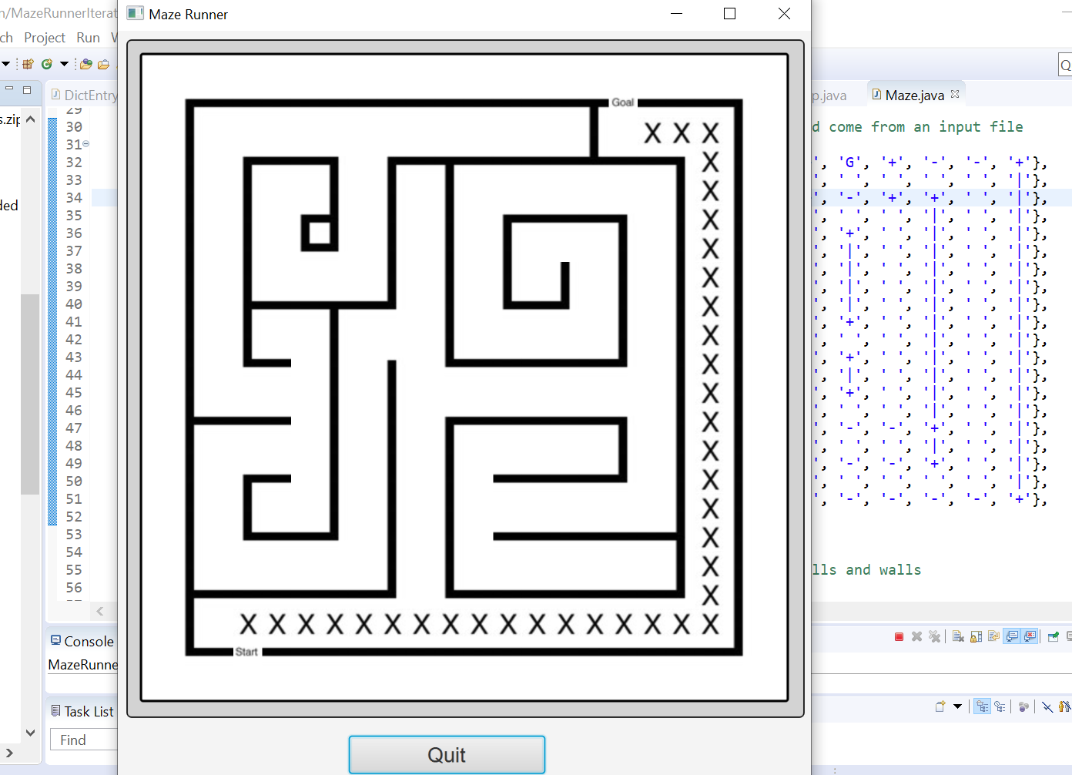

After click on the button maze is solved.

Now change the hurdle positions which has no solution:

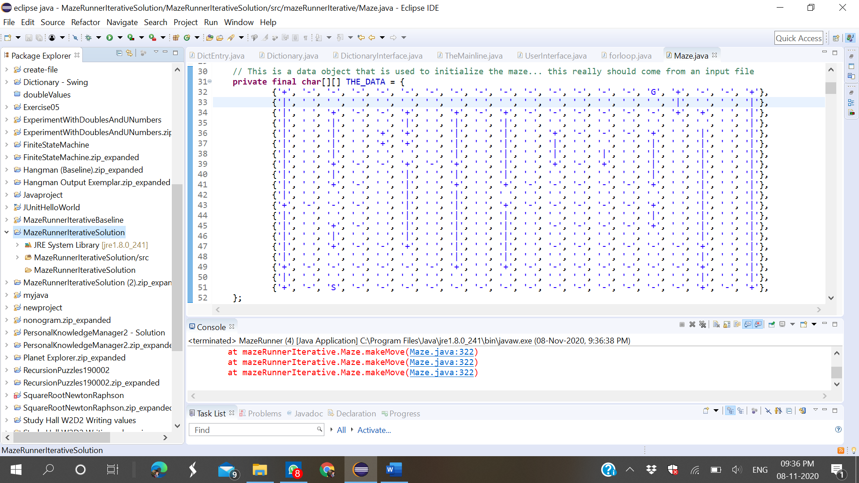

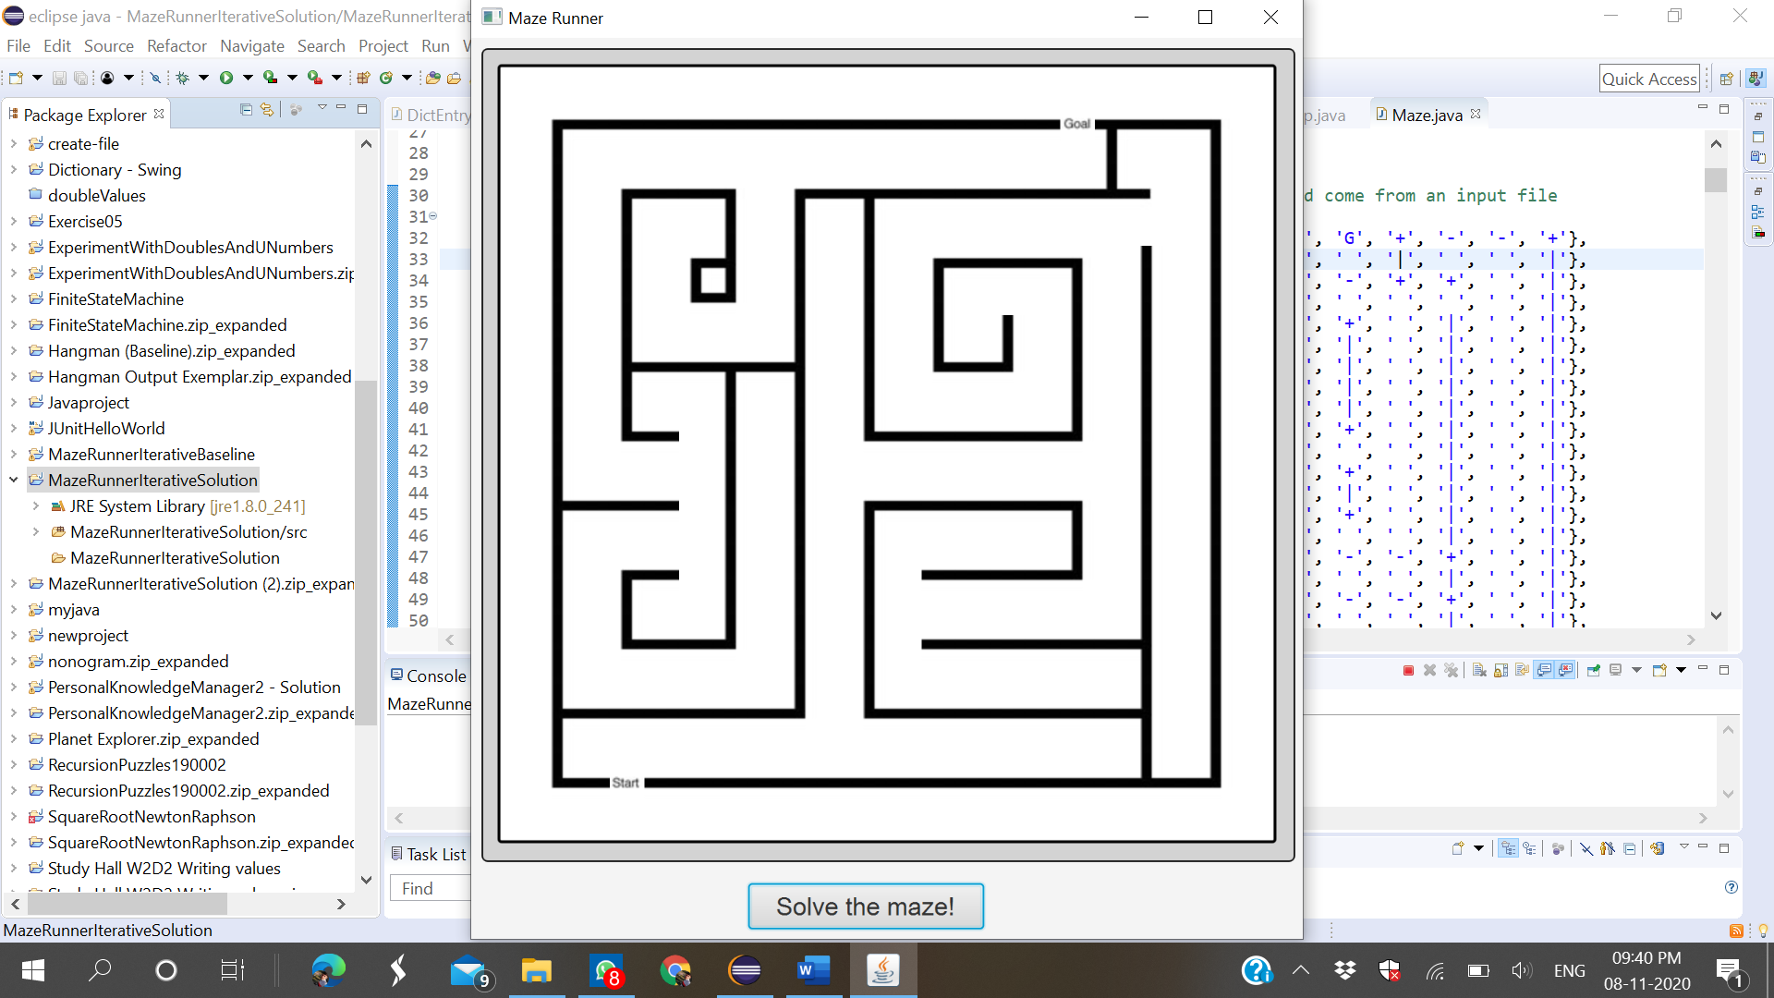

When I click on the button then it will show error because it has no solution

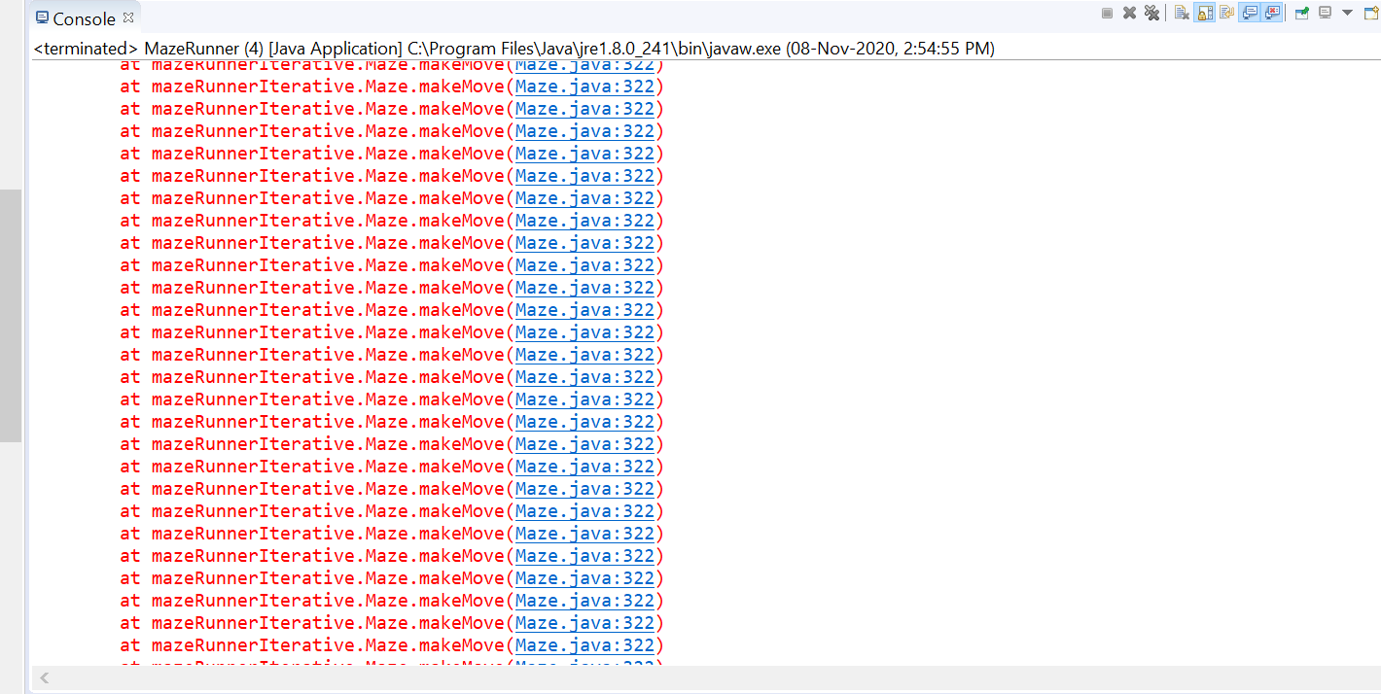

Now try with another solutions.

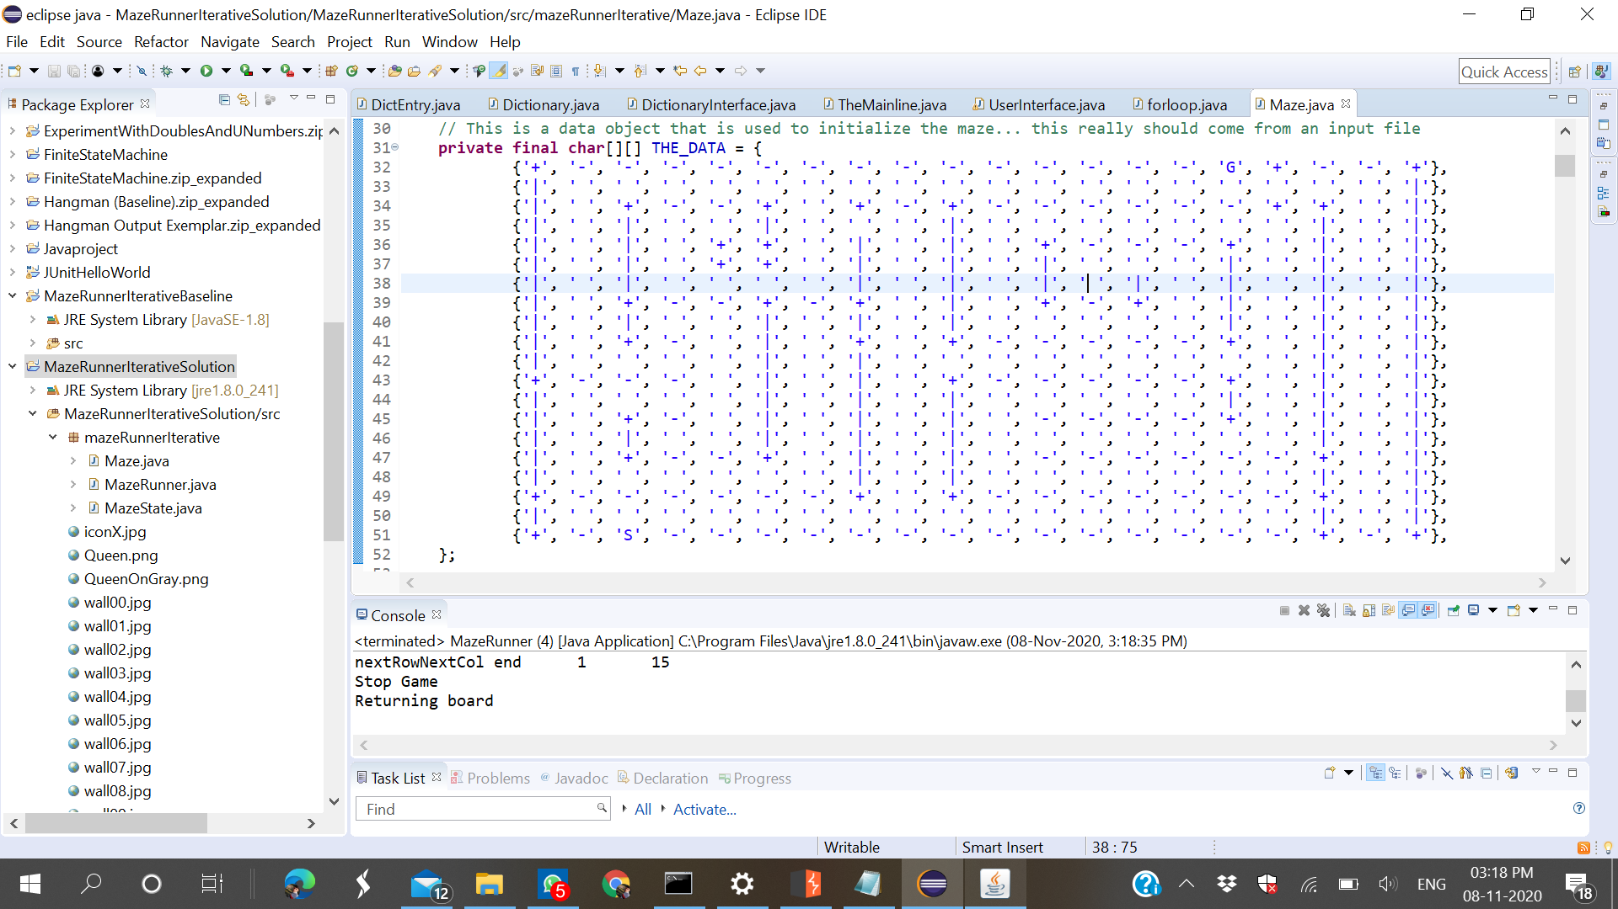

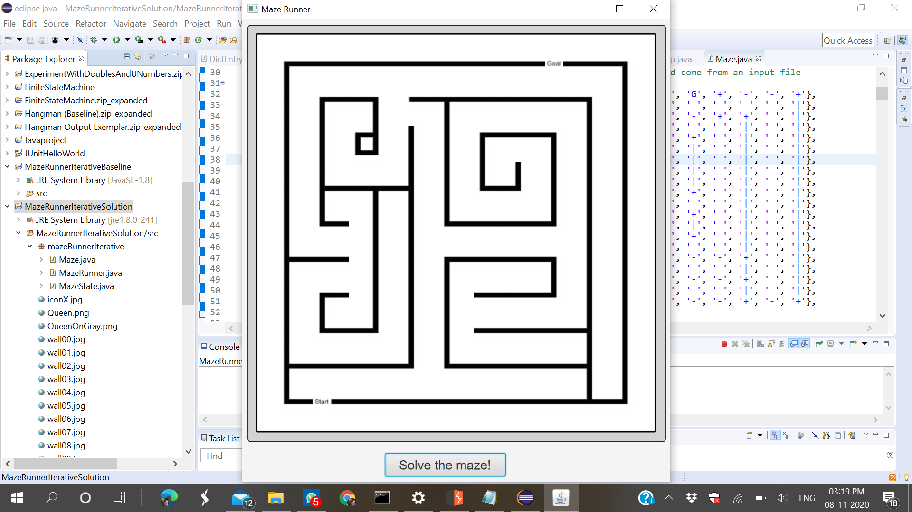

Now click on solve button to solve this maze and it will solve it.

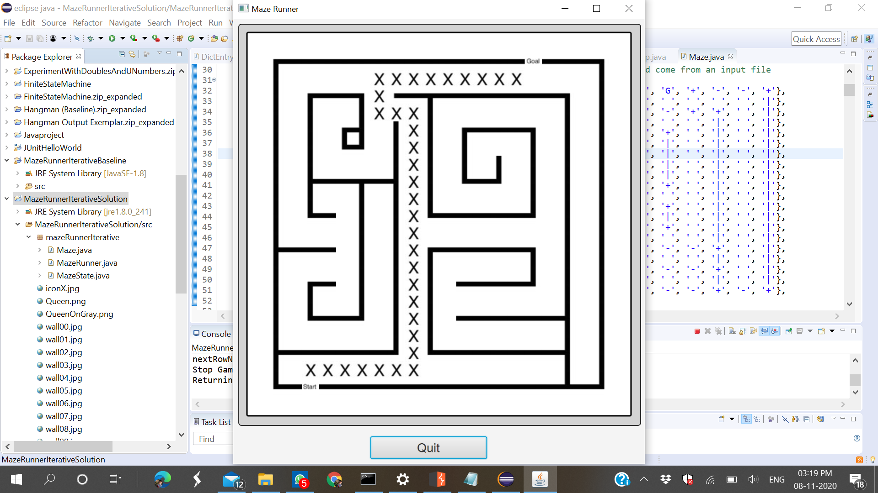

Some other solutions.

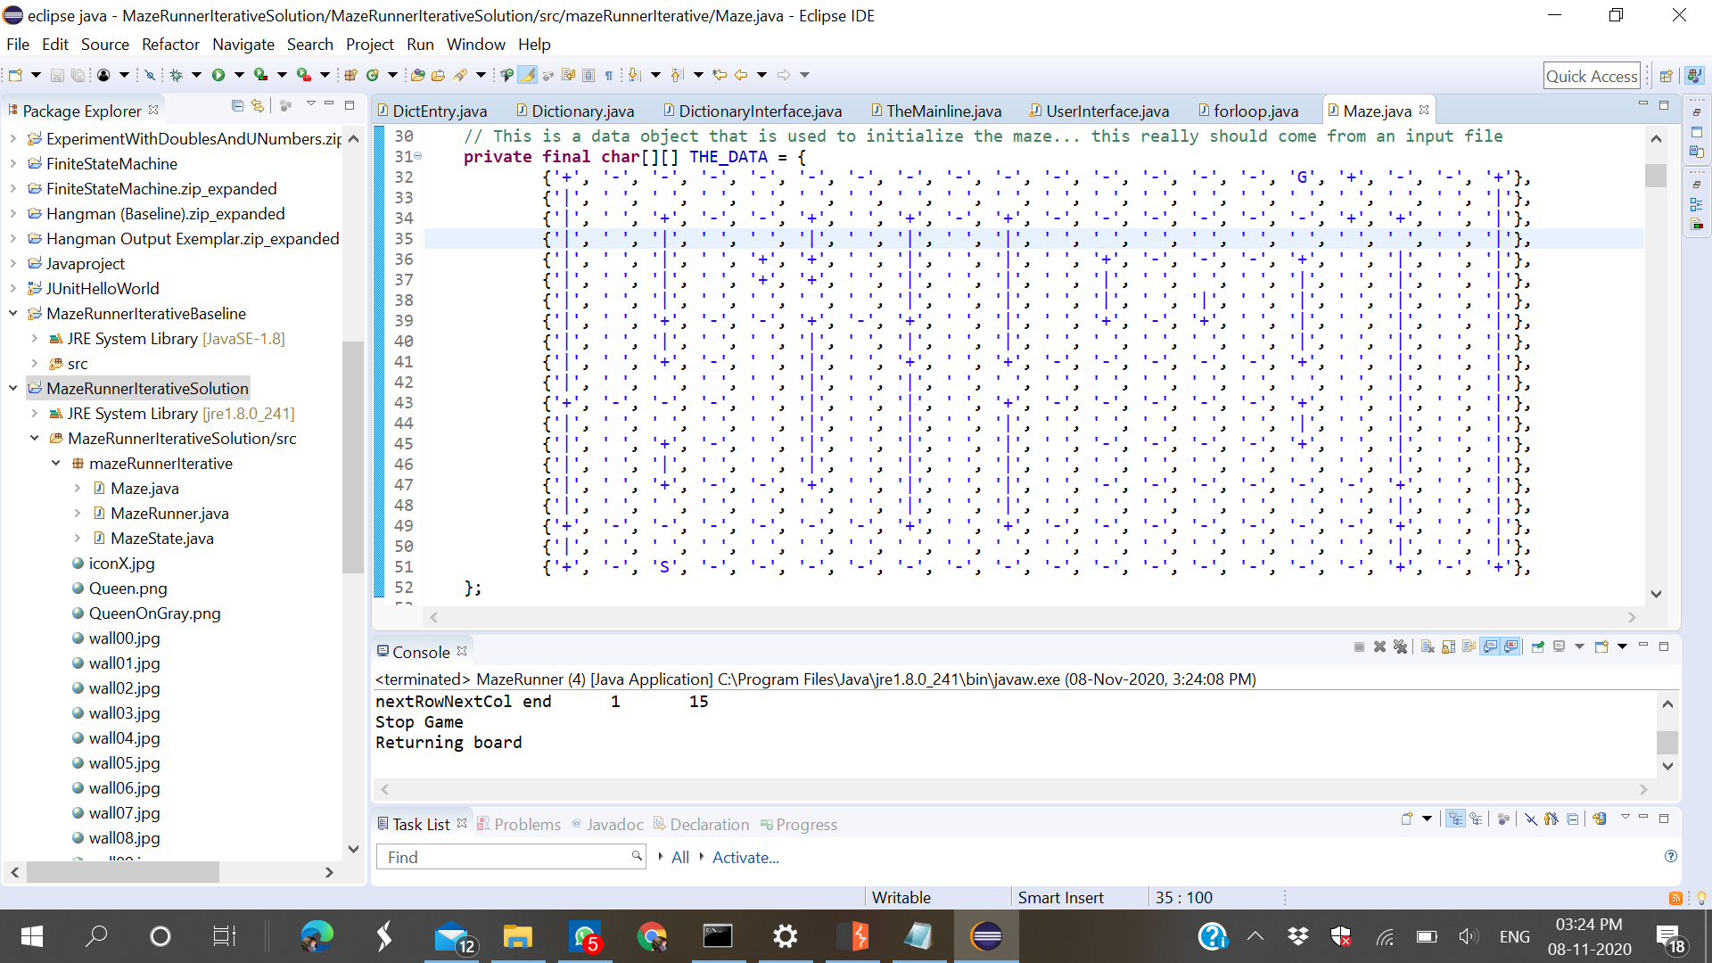

I changed the code to get other solution

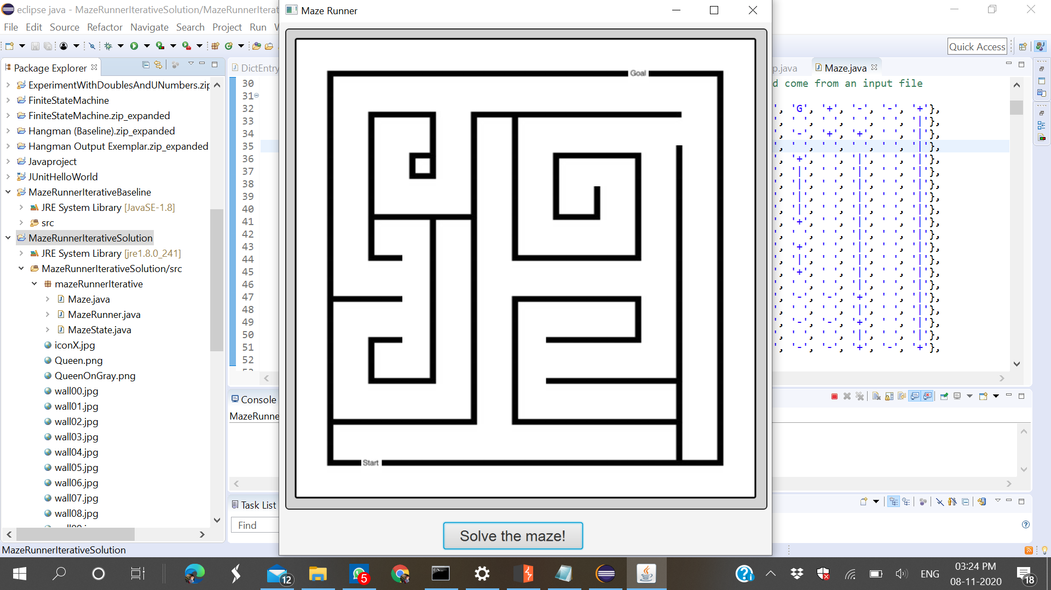

After click on solve button it solved the maze

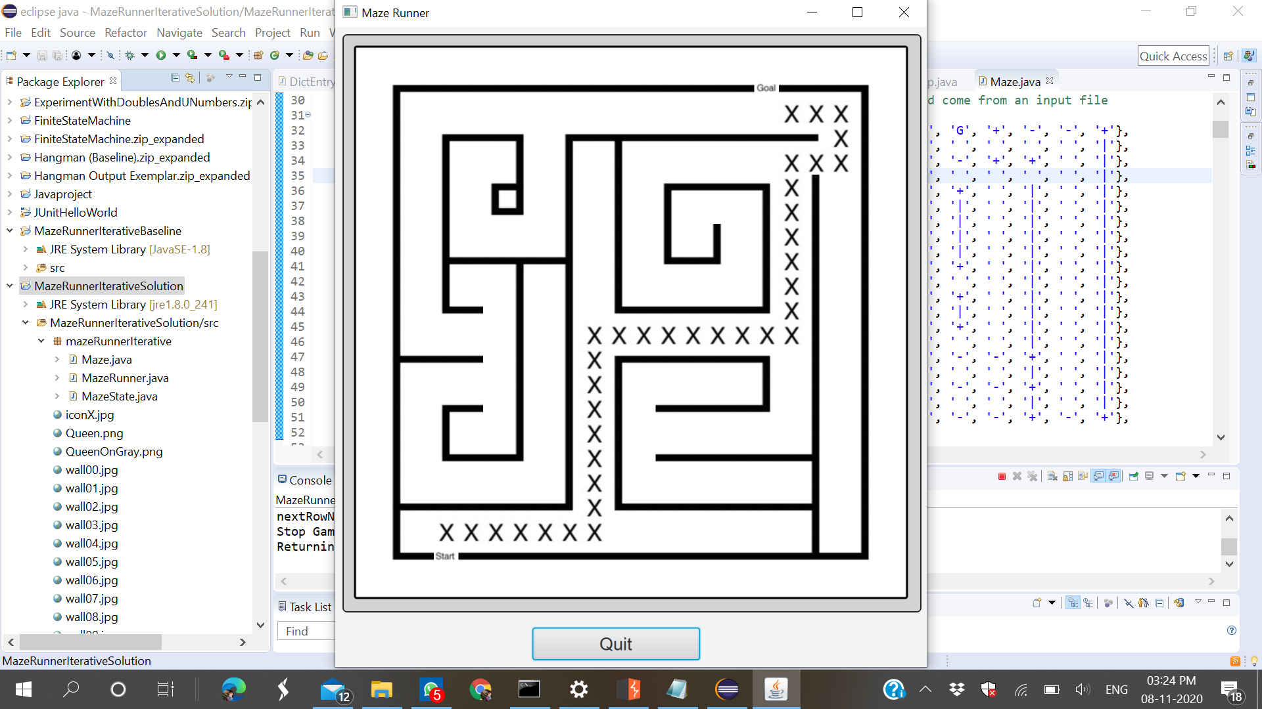

Trying some other solutions

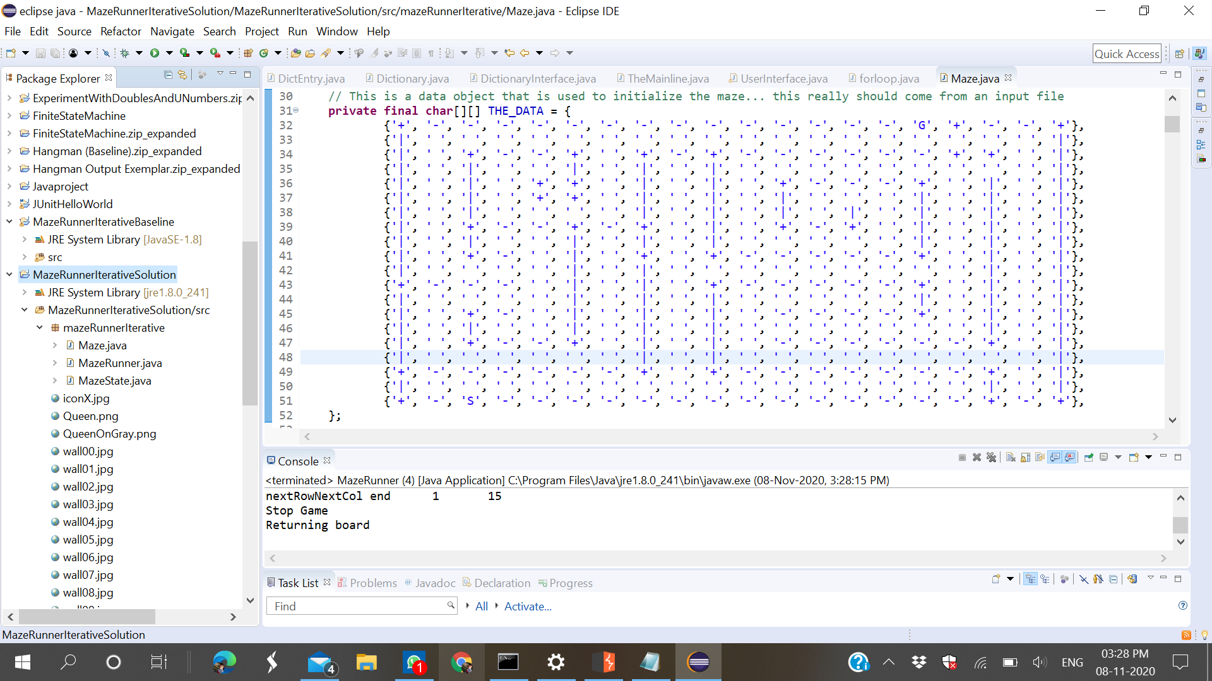

Changing the code for get other solution

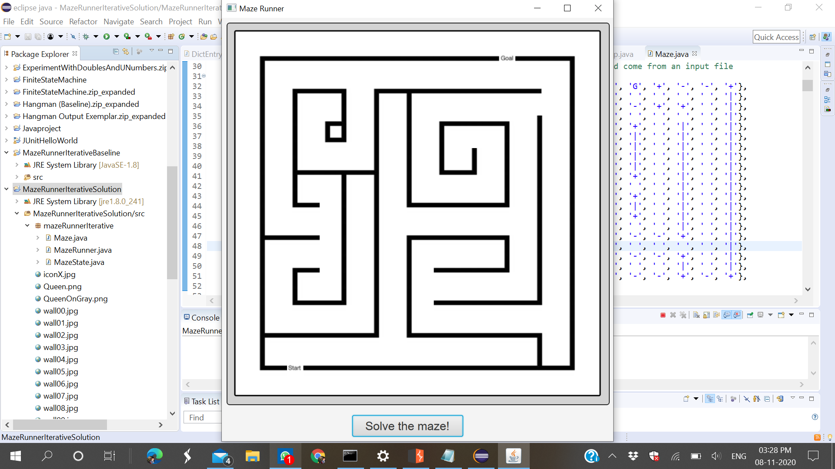

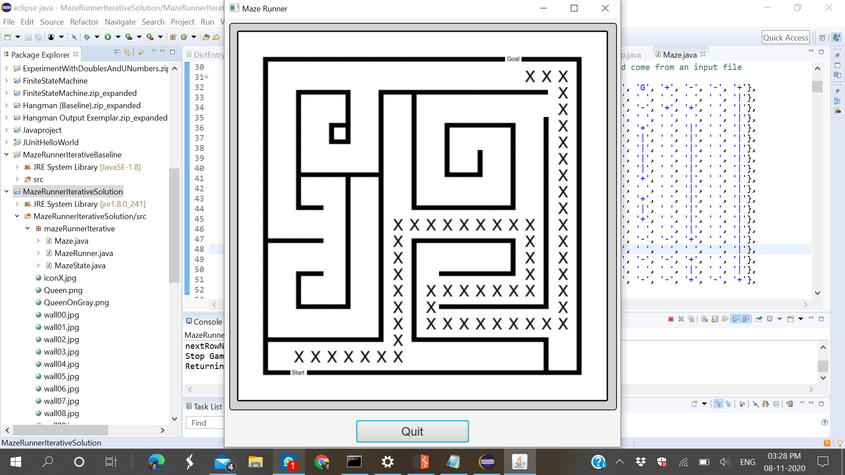

I changed maze code many times for get different-different solutions. And I confirmed that the code is working fine.